Lecture no 2

**Differentiation**

**Week no 2**

**Chapter no 2**

▪ *f’(x)* is positive where the tangent line has positive slope,

▪ *f’(x)* is negative where the tangent line has negative slope,

▪ *f’(x)* is zero where the tangent line is horizontal.

����=��3−��

��′��=3��2−1

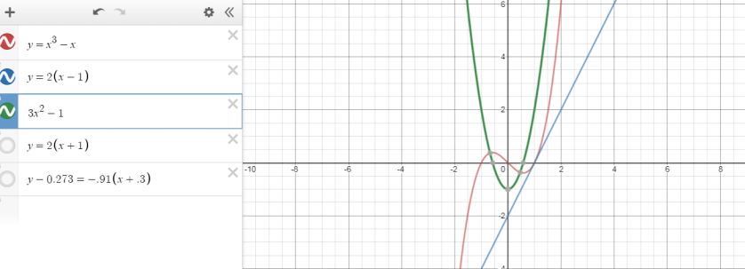

**Exercise 2.6**

Implicit Differentiation:

**Assignment No 1**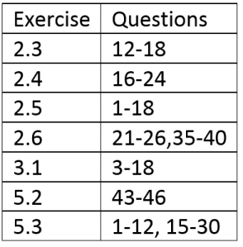

**Practice Questions:**

**Pg no 217 Exercise 3.5 Q no 1-18**

**Practice Questions:**

**Pg no 227 Exercise 3.6 Q no 7-45**